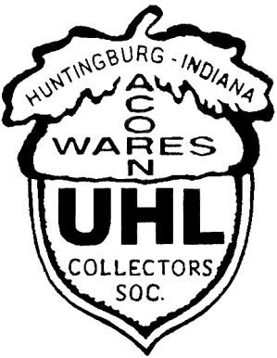

Visit us on the Web @

www.uhlcollectors.org
Russell A. Uhls

6718 Waverhill Dr. Indianapolis, IN 46217
Hm.: 317-536-8544
Work: 317-570-5830 ext. 205
Work Cell: 574-527-8994
Presorted Standard U.S. Postage Paid
Jasper, IN Permit 346

2010 Uhl Collectors’ Society
Annual Convention Friday, June 25th & Saturday, June 26th We’ll see you in Jasper!!!
Please return your Membership Renewal form
To Amy Busler before March 31st !!!

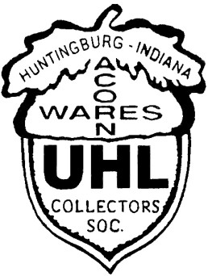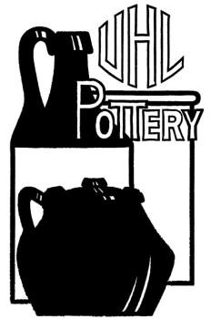Uhl Collectors Society

January 2010

**********************************************

From The President’s Desk

Here are a couple outings I attended. It was a Saturday and it turned out to be a nice one. I was at the Hilgeman Auction sale. A couple of our members had their eye on a 30 gallon Evansville crock. It had the letters UHL and Evansville, IN on its side. This is a rare piece indeed. I would have liked it to! The bidding started fast and furious with one of our members realizing their dream. They ended up owning this very rare piece at a final bid of over $1,500. I also saw a 5 Gallon Dillsboro Jug go for around $600! Wow I thought, nice Uhl pieces are holding their value! Well I didn’t get the crock, but I did get to see it.
Chip Kugler was holding another great Uhl auction at his facility behind the Jasper Inn These pieces were from the collection of Don Schwartz who had passed away in 2008. Don had been a long time member of the Society and we will miss him. A large crowd gathered and there were a couple of rare items in the selection. The Feldmeyer’s found a signed jug that they couldn’t live without. I was successful in winning an unusual ashtray. Again what a great feeling that nice Uhl pieces were selling for good prices.
This story starts on a Friday night. The usual crowd sauntered in. No it wasn’t Cheers, but everyone who was there did no my name. It was Dinky’s. One of our members found a dinky little Uhl piece hiding away. He had to part with the large sum of one dollar and the piece was his! It was truly a fine find. Say that 3 times fast!
Uhhhhhhhl! Here’s hoping your Holidays went well! Les
********************************************************************************

From the Press Secretary

Well Ladies and Gentlemen, as you can see, I finally have all the kinks worked out of the newsletter. My apologies for the lateness, but the work is now completed to the point that the next issue will be a snap. For those of you who didn’t know, the company, which has been printing our newsletter, is no longer in business. Since Roxanne and I live in Indianapolis, it worked out that it was easier to have the printing done here in Indy,
or so I thought. I won’t bore anyone with the details but the company, which came in the least expensive, did not work out. In the same breathe, the layouts and artwork that was requested by the first company did not meet the requirements needed to do the job by the second. I did not have any of the old layouts or artwork from the old printing company, so I started from scratch. Using a previous issue as a base, I believe the new version will look quite familiar to you all. A lot of new things are in the works, not in the least a new and user-friendly web site. I have started writing the code for the new pages, but it will be a while before going live. I will keep you updated. Being that we now are for the most part all connected by the Internet, if you would prefer to receive the newsletter by email, I have started a mailing list of those members requesting it by email. You may contact me
at: maundpauhls@comcast.net. You may request only an email copy or add the email copy (Continued Page 2)

What’s Inside
Page 2: Uhl Mission Statement Page 3: In Memoriam, Shirley Parker
Page 2: Press Secretary Continued Page 3: Officers & Board Members
Page 2: Notices & Information Page 3: Happenings

UHL Pottery Collector’s Society Mission Statement

The mission of the UHL pottery collector’s society is to provide an enjoyable structured group environment for those passionate about preserving, collecting & enjoying UHL pottery, which was manufactured between 1849 & 1944 in Evansville & Huntingburg Indiana.

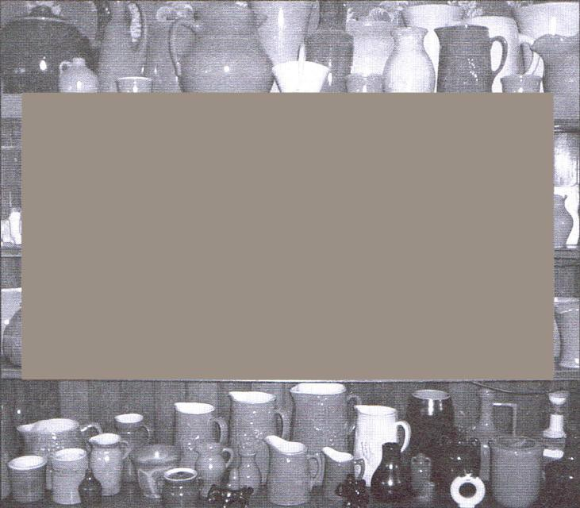A quaint Café from the mid Western part of Germany. If you have an interesting travel picture, please send it to me for a future issue!
The Auction Company
In Jasper
Chip Kugler’s next auction with Uhl will be
Saturday, March 6, 2010 - 9:00
A.M. - Schatz Estate and Others. “Several Uhl Pottery mini jugs” will be auctioned.
475 11th Avenue - Jasper, Indiana

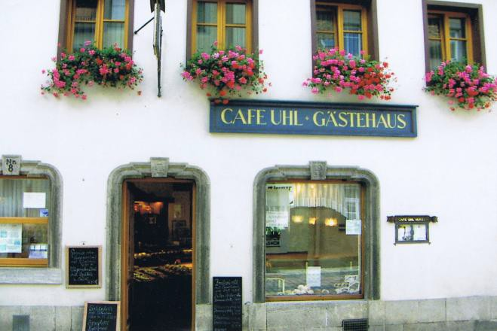Press Secretary, Continued From Page 1

along with your printed copy. By no means am I trying to force anyone to take just a copy by email. It is purely for your convenience. If on the other hand, a large portion of the members decides to receive just the email copy, it will reduce the printing & mailing cost. The first task that was requested of me by our board members was the writing of a Mission Statement for our society. I presented it to the board where it was voted on and accepted. It is presented for your reading here on page #2. If you have anything you would like to see in our newsletter, please contact me and give me your thoughts or information. It can be upcoming auctions of Uhl items, a picture of a piece you have found and would like to talk about, questions that I could research and print the answers to,
or anything that comes to your mind you think would be fun or interesting. I can’t sign off without giving you the information that a beloved member has passed away. If you did not know, Shirley Parker passed away last fall. My and I’m sure all of the society’s heartfelt thoughts & prayers go to her family. She will be missed. I am looking forward to seeing you all in Jasper June 25th. Happy Uhling & Regards, Russ Uhls

OFFICERS

President: Les Bain
973 S. Lumbard Avenue
Evansville, IN 47714
812-589-7948
email: lbain@evs.k12.in.us

Vice Pres.: Norman & Sharon Patmore
P.O. Box 706
Santa Claus, IN 47579
812-544-2069
email: spatmore@psci.net

Sec. Treasurer: Sam & Amy Busler
398 South Star
Santa Claus, IN 47579
812-544-2987
Happenings

Some of you may have noticed in the Officers listing to the left, it shows Russ & Roxanne Uhls instead of Russ Uhls & Roxanne Sirotin. On March 27th 2010, we will be married. I thought it appropriate that when we see one another again & we’ll be married by then, that all of our fellow Uhl collectors know ahead of time. Thanks to those who have wished
us luck & see you all in June!

In Memoriam

Shirley Parker

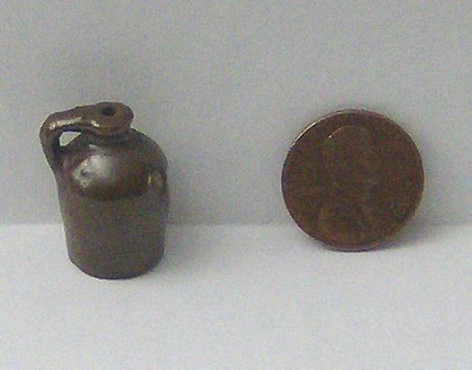You Will Be Missed

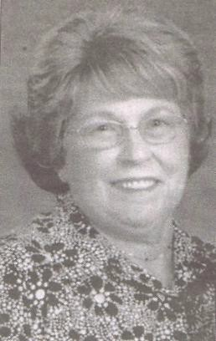email: casabusler@psci.net

Press Sec.: Russ & Roxanne Uhls
6718 Waverhill Dr. Indianapolis, IN 46217
Hm.: 317-536-8544
Work: 317-570-5830 ext. 205
Work Cell: 574-527-8994

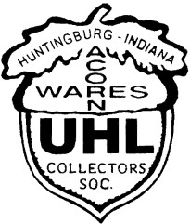

BOARD MEMBERS

Nathan Stewart
8088 N. Birch Dr. Newburgh, IN 47630
812-853-2913

Shawn & Terri Lynn Fehribach
8475 W 350 S Huntingburg, IN 47542
812-683-8380

Brian & Karla Neukam
560 Riverside Dr
Jasper, IN 47546
812-482-6168
Email: bneukam@psci.net
“My Favor ite Item”

Other than myself, I am sure that fellow members would like to see your unique or favorite item. If you send me a picture with maybe how you found it & why it’s your favorite, I will be happy to start showing pieces here in the newsletter. I’ll start it off with one of my “Treasures”. I found this on line.

It is marked “J Vhl” with a small amount of the brown glaze covering part of the bottom. Pictures of the bottom just aren’t clear enough to see. Chip Kugler & Anna Mary Feldmeyer both looked it over a few years back and blessed it. I tried the auction to sell it but it wasn’t coming up to what I would like to have gotten for it. I’ve not seen another one out there. I’ve since decided it’s too unique and it’s going to take a boatload of cash to part with it. Definitely one of my Favorites! Russ

OFFICERS

President: Les Bain
973 S. Lumbard Avenue
Evansville, IN 47714
812-589-7948
email: lbain@evs.k12.in.us

Vice Pres.: Norman & Sharon Patmore
P.O. Box 706
Santa Claus, IN 47579
812-544-2069
email: spatmore@psci.net

Sec. Treasurer: Sam & Amy Busler
398 South Star
Santa Claus, IN 47579
812-544-2987
email: casabusler@psci.net

Press Sec.: Russ & Roxanne Uhls
6718 Waverhill Dr. Indianapolis, IN 46217
Hm.: 317-536-8544
Work: 317-570-5830 ext. 205
Work Cell: 574-527-8994

BOARD MEMBERS

Nathan Stewart
8088 N. Birch Dr. Newburgh, IN 47630
812-853-2913

Shawn & Terri Lynn Fehribach
8475 W 350 S Huntingburg, IN 47542
812-683-8380

Brian & Karla Neukam
560 Riverside Dr
Jasper, IN 47546
812-482-6168
Email: bneukam@psci.net

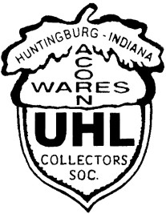2010 Membership Form

____

NEW MEMBERSHIP # RENEWAL

Last Name First Spouse or Guest Name

Address

Telephone Email

1. Dues for January 1 – December 31 $15.00

2. Commemorative MAILED $45.00

3. Friday Banquet $9.00 per plate for Member & Spouse (1-2)

4) Friday Banquet $17.00 per plate for Guest (one per member)

5. Tables for Saturday Sale NO CHARGE Total Needed

Membership, Commemorative and Meals TOTAL $

DEADLINE IS MARCH 31, 2010------NO EXCEPTIONS
Please take not that only one guest per membership except for children under 15 years of age. Each guest meal is $17.00

CONVENTION RESERVATIONS June 25 & 26
Jasper Inn in Jasper Indiana
1-812-482-5555
This number is for room reservations only!

Please send completed form with check or money order to: Uhl Collectors Society
C/O Sam and Amy Busler
398 S Star Dr
Santa Claus, IN 47579

The business meeting June 26th at 9:00 AM is open to members only. If any questions call 1-812-544-2987

Please Note: ALL commemoratives will be mailed again this year!

